**Dietary fibers induce dynamical and individualized response in mice gut microbiota and short-chain fatty acids production**

Running title: Quantitative modeling of longitudinal microbiome-metabolome data reveals biphasic and baseline-dependent response of mice gut microbiome to dietary fiber

**Hongbin Liu*, Chen Liao*, coauthors, Lei Dai#**

**Affiliations**

**Abstract**

Dietary fibers are commonly used as an intervention of gut microbiome to promote the production of short-chain fatty acids (SCFA), which are important for host health. However, the response after dietary fiber interventions is still poorly understood due to the lack of time series data on both microbiome and metabolome. Here we used adult mice with different baseline microbiota to study the dynamical and individualized response of gut microbiota following interventions of inulin and resistant starch. We found dramatic shifts dynamics in mice gut microbiome composition and SCFA metabolism over four weeks. We used gLV to infer microbial ecology and successfully identified primary degraders. Furthermore, we used machine learning models to identify bacteria taxa associated with SCFA production, which can explain the individualized response to some degree but fails to predict the response of gut microbiome with a different baseline composition. Finally, we propose that SCFA production of gut microbiome in response to dietary fiber may have different phases. Our work underscores the importance of understanding the dynamical and individualized response in gut microbiome.

**previous version**

(*Background*)

Longitudinal microbiome-metabolome monitoring at an individual level enables deep physiological and mechanistic profiling and may provide an important tool for precision nutrition, which aims to prevent and manage chronic diseases by tailoring dietary interventions or recommendations.

(*Goal*)

Using mice that harboring different gut microbiome as model hosts, we assess the dynamic response of the gut ecosystem to dietary fiber intervention by integrating analyze longitudinal data from the gut microbiome and SCFA metabolome.

(*Result*)

Regardless of the different baseline microbiome, we identified a strong short-term response and long-term adaptation of the gut microbiome in response to inulin intervention, representing by the substantial changes in the microbial structure and total SCFAs metabolism that happened a few days after the start of the intervention diminished before approach a final stable state. This biphasic response was consistent observed when reanalyzed another published dataset. However, the magnitudes and rates of the biphasic response dynamics of individual SCFAs and specific microbes were variable and identifiable influenced by pre-treatment microbiota. By coupling microbial quantity data and inferring with dynamic models, we verified multiple SCFAs producers that previously reported (*Parabacteroides goldsteinii*, *Lachnospiraceae bacterium 28-4*, *unclassified_**Desulfovibrionaceae*, *Bacteroides-acidifaciens*), with their dynamics significantly correlated with the temporal changes of SCFAs concentrations. Furthermore, *Bacteroides-acidifaciens*, a species that previously reported for its involvement of inulin’s primary degradation, was again identified as inulin-responder here, along with a novel identified inulin-responder family *Muribaculaceae*. The different preintervention abundance of these two inulin-responders could result in distinct dynamic responses to inulin intervention. Through applying the quantitative modeling analysis to published human longitudinal microbiome data, we identified previously reported bacteria that may engage in the primary degradation of inulin or resistant starch. Our study highlights the importance of longitudinal sampling and integrating complementary multi-omics data to identify temporal dynamics of the microbiome. Serving as a widely-applied framework, this quantitative modeling method reveals insights into the ecologic mechanisms that how dietary fiber reshape the gut microbial structure and SCFA metabolism, which will help improve existing dietary treatments and guide precisely manipulation of the gut microbiome for optimal medical care.

**Introduction**

1. **Microbiome modulation by diet: importance**
2. **Dietary fiber -> SCFA production**
3. **Dynamical response (microbiome+metabolome) after dietary intervention: lack of understanding**
4. **Individualized response after dietary intervention: call for precision nutrition**
5. **This study**

There are hundreds of trillions of microbes reside in the human gastrointestinal tract, which have a profound impact on modulating host health and physiology [1]. Disruptions in the delicate dynamic balance of microbes within the gut are associated with numerous disease states. For instance, deficiency in the production of short-chain fatty acid (SCFA) has been not only associated with the occurrence of type 2 diabetes mellitus, obesity and inflammatory bowel disorders [2], but also affect the treatment of these diseases [3]. Accordingly, there is intense interest in targeting the structure and metabolism of gut microbiome to promote overall health and to abrogate disease [4]. Among gut microbiota modulation strategies, the use of prebiotic supplementation (such as inulin and resistant starches), which could provide optimal substrate to beneficial commensal microbes and thereafter promote the production of SCFAs, has shown promise in treating several disease conditions [5, 6]. However, different microbial response among individuals were observed for the same dietary fiber, resulting in various intervention outcomes. Indeed, Valcheva et al. document heterogeneous responses in fecal butyrate concentrations upon inulin supplementation, which have been significantly associated with the alleviation in the intestinal inflammation of ulcerative colitis patients [6].

Individualized microbial responses to dietary fiber have been extensively studied. However, most of these studies are based on cross-sectional study design and only provides a snapshot of a highly dynamic ecosystem, regardless of the fact that the response of microbial system to dietary fiber could has time-scale characteristics [7]. For instance, from the microbial ecological angle, metabolism of dietary fibers in the gut can be a complex process mediated by many different microbes that can interact synergistically over time. Primary degraders perform the initial depolymerization of polysaccharides and produce mono-, di-, and oligosaccharides, which can be utilized by another bacterial species grows and thereafter ferment to acidic end products such as lactate or SCFAs [8]. These cross-feeding interactions could be directly captured by the longitudinal cascading alteration profiles of gut microbiome in response to dietary fibers, such as delayed succession of bacterial blooms of secondary degraders compared to primary degraders [9]. Notably, many of these degraders are specialists, attacking specific bonds in specific types of polymers [10, 11]. Only a limited number of gut bacteria may be able to degrade any given dietary fibers. Therefore, it is reasonable that the various presence and abundance of these specific degraders among individuals prior to dietary fiber supplementation could induce personalized microbial responses and outcomes [12]. As such, to improve the clinical efficacy of dietary fiber interventions, it is critical to understand how members of the gut ecosystem respond as individual strains as well as how they interact with one another as functional groups when exposed to increased fibers as a new environmental resource.

Owing to the large variation in microbial profiles between people, with relatively smaller variation within subjects over time, longitudinal multi-omics study designs have the potential to be higher-powered than purely cross-sectional studies, particularly in their ability to self-control individuals and to capture variation within an individual over time, between individuals, and interactions in different types of molecule and microorganism [13]. On the other hand, to capture the individualized microbial response and potential “keystone” degraders of the dietary fiber, individuals harboring distinct gut microbiome are required [12].

In the present study, using mice that harboring different gut microbiome as model hosts, we assess the dynamic response of the gut ecosystem to dietary fiber intervention by integrating longitudinal data from the gut microbiome and SCFA metabolome. We observed a universal transition between short-term response and long-term adaptation of the microbial metabolism in response to dietary fiber intervention, which was independent of the pretreatment microbial configuration. Through dynamic modeling analysis, we identified a consortium of microbes that affect the degradation of inulin and subsequent SCFA fermentation. The pretreatment abundance of *Bacteroides-acidifaciens* and *Muribaculaceae* together determined the individualized dynamic responses of the microbial composition and propionate production.

**Results**

**Section 1: study design, analytical framework**

*Probing the temporal behaviors of gut microbiome in response to dietary fiber*

We aimed to dissect the microbial dynamic responses to the dietary fiber intervention, which has shown promise in optimizing gut microbiome structure to treat several disease conditions. To this end, the shifts of composition and SCFAs metabolism of gut microbiome C57BL/6J mice before and after starting either cellulose (control) or inulin (high fiber) feeding were longitudinal monitored (**Fig 1A**). Cellulose was used as a negative control due to its low fermentability and consequent low SCFA production. Inulin is a well-documented microbiota assessable carbohydrate characterized by selectively promoting the growth of beneficial microorganisms and SCFA production. To mirroring the response of personalized gut microbial system in humans while controlling confounding variation between individuals that driven by environmental differences and other host differences, age- and gender-matched isogenic mice for different gut microbiome were purchased from four different commercial vendors. As expected, we observed significant differences in the microbiota composition of mice purchased from the four independent breeder sources, despite being housed in the same environment and fed the same cellulose-based diet 7 days prior to analysis (**Fig 1B**). Bray-curtis distance further confirmed a different distribution between different vendor-purchased mice (**Fig 1C**).

Multiple measurement types of the gut microbiome from longitudinal stool specimens of each mice were generated. The temporal variations in community structure were accessed using 16S rRNA gene sequencing. Since model construction is aided by absolute abundance information, the coupling total biomass was monitored using qPCR. In addition, a paralleling targeted metabonomic approach was used to determine the dynamics of SCFAs concentrations. Through metagenomic sequencing, functional shift of the gut microbiome (e.g. gene abundance of inulinase) was documented. To understand how members of the gut ecosystem respond as individual strains as well as how they interact with one another as functional groups and thereafter promote the SCFA production when exposed to inulin, multiple methods were employed to dissect the metabolic process of inulin from degradation to SCFA production. Generalized Lotka–Volterra (gLV), an ordinary differential equation model that represents microbial communities with a limited number of parameters that can be deduced from time-series data, was employed to identify candidate inulin degraders. The Random Forest (RF) model, together with elastic net regression model, was performed to identify potential SCFA producers. Finally, an inulin-derived bacterial food chains model was proposed by integrating these information together, which helped us understand the individualized biphasic responses of gut microbiome from an ecological perspective.

**Section 2: dynamical response of microbiome and metabolome**

*Distinct pretreatment microbiome feature consistent* *biphasic response to dietary fiber*

Inulin feeding led to similar or slightly higher body weight compared to the cellulose group (**Supplementary Fig 1**). Although the inulin-based diet had a significant effect (*P* < 0.01) on the food intake in three vendors, extremely small differences (less than 1g/cage*day) indicated that the effect is negligible (**Supplementary Fig 1**). However, the 48-h fecal output was significantly decreased in the inulin group than in the cellulose groups (**Supplementary Fig 1**). In line with the decreased fecal output, samples from inulin-fed mice consistently exhibited higher fecal bacterial density, signaling a longer colonic transit time that available for colonic microbial fermentation of dietary substrate in inulin groups (**Supplementary Fig 1**).

Most prominently, regardless of the different baseline structure, a consistent biphasic response was observed among vendors in the SCFA production: after initial elevates, the total SCFA returned to but higher than its original baseline state for the remainder of the intervention, despite mice maintaining their diet for the entire study (**Fig 2A**). The magnitudes and rate of the responses of individual SCFAs were, however, vendor-specific. The most pronounced responses of individual SCFAs to inulin treatment were observed in mice from Guangdong; in contrast, mice from Beijing and Hunan showed mild increase in acetate and butyrate, whereas mice from Shanghai showed gradually increase in propionate (**Supp Fig 2E**).

In a parallel trend, the composition of gut microbiome in inulin and RS mice exhibited biphasic fluctuation as well. Shannon index (a diversity measure that takes into account both richness and evenness) was employed for analyzing the effect of inulin intake on the alpha diversity of the gut microbiota. Results depicted a similar biphasic dynamic pattern among four vendors (**Fig. 2B**), wherein inulin appears to cause an initial decrease in the Shannon diversity, and thereafter returned near its original baseline state for the remainder of the intervention. The magnitudes of these responses were different among vendors, with the initial decrease were considerably slight in Shanghai than in the other three vendors (**Fig. 2B**). To further determine the biphasic shift of gut microbiota during the experiment, we tracked the volatility in beta diversity (weighted UniFrac distance) after pairing using the “first distances” method [14]. We assessed how an individual gut microbiome community differed from the baseline (day 0) over time (**Fig. 2C**). Compared to cellulose group, the community structure in inulin mice showed a dramatic shift in the first few days, which thereafter reversed near to its original baseline composition. The occurrence day of these initial responses was individualized, ranging from around day 5 for Beijing, Guangdong, and Hunan, and around day 19 for Shanghai. To access the robustness and reproduceable of these findings, we re-analyzed the raw data from a recent longitudinal study [15]. This study tracked the 16S rRNA gene microbiota compositions of mice after inulin intervention sampled from day 0 to day 14. Indeed, we found similar results in the mice: after initial shifts of response, the gut microbiome returned near to its original baseline composition (**Supp Fig. 2C**). Thus, this further validated our observation and indicated that the biphasic responses of gut microbiome to dietary fiber intervention are likely widespread.

For additional insight into the biphasic response, we plotted the abundance of the observed taxa at genus level for each vendor over time (**Fig. 2D**). As expected, for both inulin and RS intervention, we observed changes within the first 5 days relative to baseline; however, these changes were not sustained throughout the remainder of the experiment. For instance, the *Bacteroidales* increased from day 0 to day 1 but decreased thereafter in inulin mice from Beijing, Guangdong and Hunan. Family *Muribaculaceae* increased from day 0 to day 3 in inulin mice from Beijing and Guangdong, whereas decreased from day 20 to day 31 in inulin mice from Guangdong. Apart from the consistent responses among vendors, several gut microbes showed different shifts between vendors as well. For instance, the increase of family *Muribaculaceae* in initial days was only observed for inulin group from Beijing and Guangdong, which showed an time-delayed trend and started from day 19 for Shanghai instead. Bacteria *Akkermansia* of the inulin group, a genus that often observed to increase in abundance after prebiotic treatment [16], showed an enrichment from day 5 and day 19 for Hunan and Shanghai mice, respectively, but no change was seen for Beijing and Guangdong mice. Many studies have shown that inulin has a bifidogenic effect [17]. Here, our study confirms the bifidogenic nature of inulin (**Supp Fig. 2C**), which has been attributed to the ability of genus to efficiently take up and intracellularly degrade larger fructo-oligosaccharides [18].

When comparing inulin to the resistant starch group, remarkably lower responses were observed to the latter dietary intervention in terms of the microbial composition and SCFA metabolism changes (**Fig 2A-D**). Taking the inulin group as an example, we performed metagenomic sequencing at day 5 and 31 to gain insights into the functional shifts that may support for the biphasic response observation. The PCoA analysis of gene family abundance showed that samples from two timepoints clustered distinctly from each other for three vendors, demonstrating a significant shift from day 5 to 31 that may mirror the functional transition from short-term response to long-term adaptation (**Fig 2E**).

Overall, these findings, together with findings from re-analysis of the independent study data, suggest a widespread microbial biphasic response to dietary fiber intervention, which consists of initial changes in composition, function and SCFA metabolism, and long-term adaptation showing diminish and even disappear of these initial changes. However, the findings also emphasize that both the magnitude and rate of microbial compositional and SCFA metabolism were depend on the pre-intervention microbial configuration.

**Section 3: inference of dietary fiber responders by gLV**

*Longitudinal GLV-model identify bacterial responders and downstream interactions mirroring bacterial food chain of inulin*

This argues that *Muribaculaceae* and *B. acidifaciens* have pivotal roles in fermentation of inulin in the mouse large intestine. Variation in the occurrence of this two inulin-responders may be a primary cause of variable dynamic responses of SCFA among three vendors.

*Muribaculaceae*: The abundance of Muribaculaceae, for which the name family S24-7 was previously used, was reported to be increased by inulins in previous studies, and this family was versatile with respect to complex carbohydrate degradation (Sequence and cultivation study of Muribaculaceae reveals novel species, host preference, and functional potential of this yet undescribed family).

*B. acidifaciens:* previously reported inulin-responder (Single-cell genomics of uncultured bacteria reveals dietary fiber responders in the mouse gut microbiota)

**Section 4: prediction of SCFA metabolism by machine learning**

**Section 5: the relation between microbiome composition and SCFA at different timescales**

**Discussion**

1. **Dynamical response: how and why**
2. **Individualized response: how and why**
3. **Human data, new insights from meta-analysis**
4. **Limitations**
5. **Novelty, insight for future research**

Key bacteria determine the response of gut microbiome to dietary fiber

The release of oligosaccharides from inulin in the mouse colon may depend on the presence of *Muribaculaceae* or *B. acidifaciens* within the microbial community.

Consistent with previous reports [11, 24], the abundance of *Ruminococcus* increased and here identified as resistant starch responder, which has been proposed to be a keystone species for the degradation of resistant starch [11].

Four studies showed an increase in Faecalibacterium after inulin exposure [6, 36-38].

Low reproducibility between studies because of the individualized gut microbiome

The impact of dietary fibers on the gut microbiome has been widely studied. However, rare consistent and reproducible microbial responses were yielded among these studies, and this “reproducibility crisis” has been attributed to the substantial variation in pretreatment gut microbial configuration.

Representative of fecal SCFA concentration

Quantification of human intestinal SCFAs only provides steady state levels and may not accurately reflect the level of bacterial production as most SCFAs produced in the colonic lumen (90–95%) are absorbed by the gut mucosa [21]. Nevertheless, the analysis of SCFAs in fecal samples is used as an approximation of gut levels, since excreted SCFA concentrations correlates well with colonic acetate status[19, 20], and are associated with RS enriched diets (substrates of SCFAs-producing bacteria), inferring the relationship between intestinal SCFAs production and fecal levels [22-24].

healthy microbiota are resilient to temporal changes by dietary fiber

Recent studies have suggested that diet is a key modifiable environmental factor which could rapidly and reproducibly alters the human gut microbiome that, in turn, could impact human physiology. However, these changes only last as long as the dietary fiber is consumed [25-28]. The transient nature of these diet-induced microbial changes disappearing shortly after cessation of a dietary initiative suggest that continual intake of the nutritional substrate may be required. As such, a sustainable dietary regime is supposed could maintain the dietary effect on gut microbial composition and thereafter support the emergent of a new microbial ecology state [29]. Surprisingly, however, we found that even a prolonged dietary regime still could not sustain the microbial alterations observed in short-term intervention. There was a strong long-term adaptation of the microbial metabolism in response to inulin intervention, representing by the substantial changes in the microbial structure and total SCFAs metabolism that happened a few days after the start of the intervention diminished before approach a final stable state. This biphasic response was reproducible when reanalyzed another published dataset. This is in line with previous research in humans, showing that the production and concentration of SCFAs in response to treatment with fiber in patients with colonic cancer dropped down after the initial elevation before sixth week [30]. These findings suggested that the biphasic response is widespread and independent of the pre-treatment microbial profile. indication of microbial resilience to perturbation of the microbiota’s baseline profile. On the other hand, this return trend of gut microbiome reflects that healthy microbiota are resilient to temporal changes by dietary fiber, meaning that homeostatic reactions restore the original community composition, as recently shown in the case of bread [31, 32].

A study in mice showed that changes in the microbiota of mice consuming a low-MAC diet are largely reversible within a single generation. However, over several generations, a low-MAC diet results in a progressive loss of diversity, which is not recoverable after the reintroduction of dietary MACs [33].

In this lot of mice, we observed different microbiota compositional changes compared to the previous experiment, such as an increase in *Bifidobacteriaceae* in Beijing [17]. This variation in the level of bifidogenic effect of inulin was suggested caused by the individualized initial abundance of bifidobacterial in the gut [34, 35].

Numbers vary by several logs between individuals and in some people they are undetectable(19, 20). Therefore, other bacterial groups might replace bifidobacteria as the main consumers of inulin in those individuals.

As succinate-producing bacteria, *Prevotella* can participate in the degradation of inulin [39].

A recent study discovered that parasitic gut worms (in particular, *Trichuris muris*, a whipworm) survive and reproduce easier in mouse gut tracts that have higher levels of fermentable dietary fiber such as inulin [42].

These findings have important implications for future studies and the need for dense temporal sampling experimental designs and computational methods capable of analyzing such data in detail. Endpoint studies or analyses looking only at responses of dominant taxa will miss time-varying behavior and less abundant organisms that may still be biologically relevant. Overall, the diverse response patterns of taxa may be important for evaluating glycan effects on human health. For instance, knowledge of response rate kinetics could be important in determining the timing and length of treatment to take into account both faster and slower responding taxa.

**The experimental design and the analytical frameworkto study the**

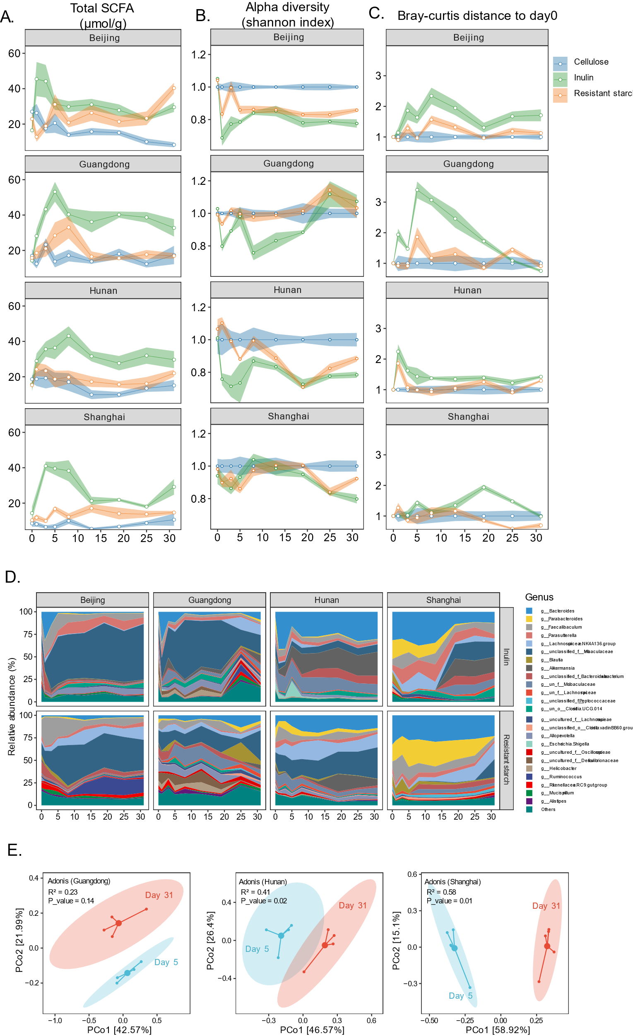

**Figure 2.** **Dynamical response of the microbiome composition and SCFA metabolism to dietary fiber intervention.**

(A) SCFA concentration in fecal samples over time.

(B) Alpha diversity in terms of shannon index in fecal samples over time.

(C) Beta diversity in terms of aitchison distance to day 0 in fecal samples over time.

(D) Dynamics of the fecal microbial composition of inulin group mice from three vendors at genus level.

(E) Principle coordinates analysis (PCoA) of the metagenomic gene abundance based on the bray-curtis distance showing shift of the fecal microbial function between short- (day 5) and long-term (day 31) intervention in inulin mice.

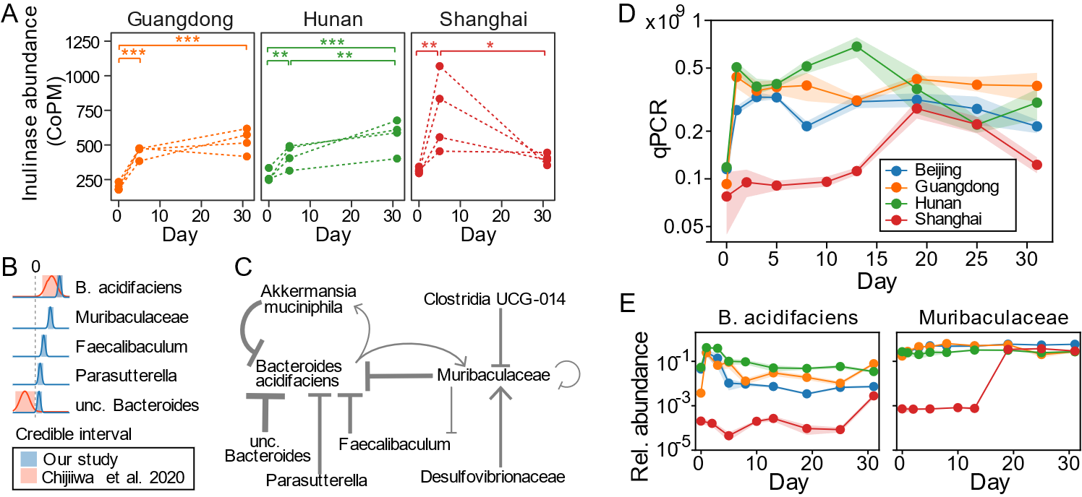

**Figure 3. Identification of inulin responders using the gLV model.**

Add transition using the two-step framework (Supplement, optional): primary degradation, SCFA fermentation. No need to label specific species.

Change orders:

A)metagenome data, gene abundance increases.

Explain the model! Used cellulose group(in our study) or day 0 (Chijiwa)

B) growth rate (connect to methods/Figure 1). Supp table to support B, validated. Chijiwa data only has relative abundance (can move to supp figure).

E) show other 3 responders in supplement

D) the relative abundance of inulin responders determines the response/increase in absolute abundance?

C) interaction network: competition among inulin responders (highlight), remove self-inhibition

Supplement: difference in composition before and after intervention ->Hongbin

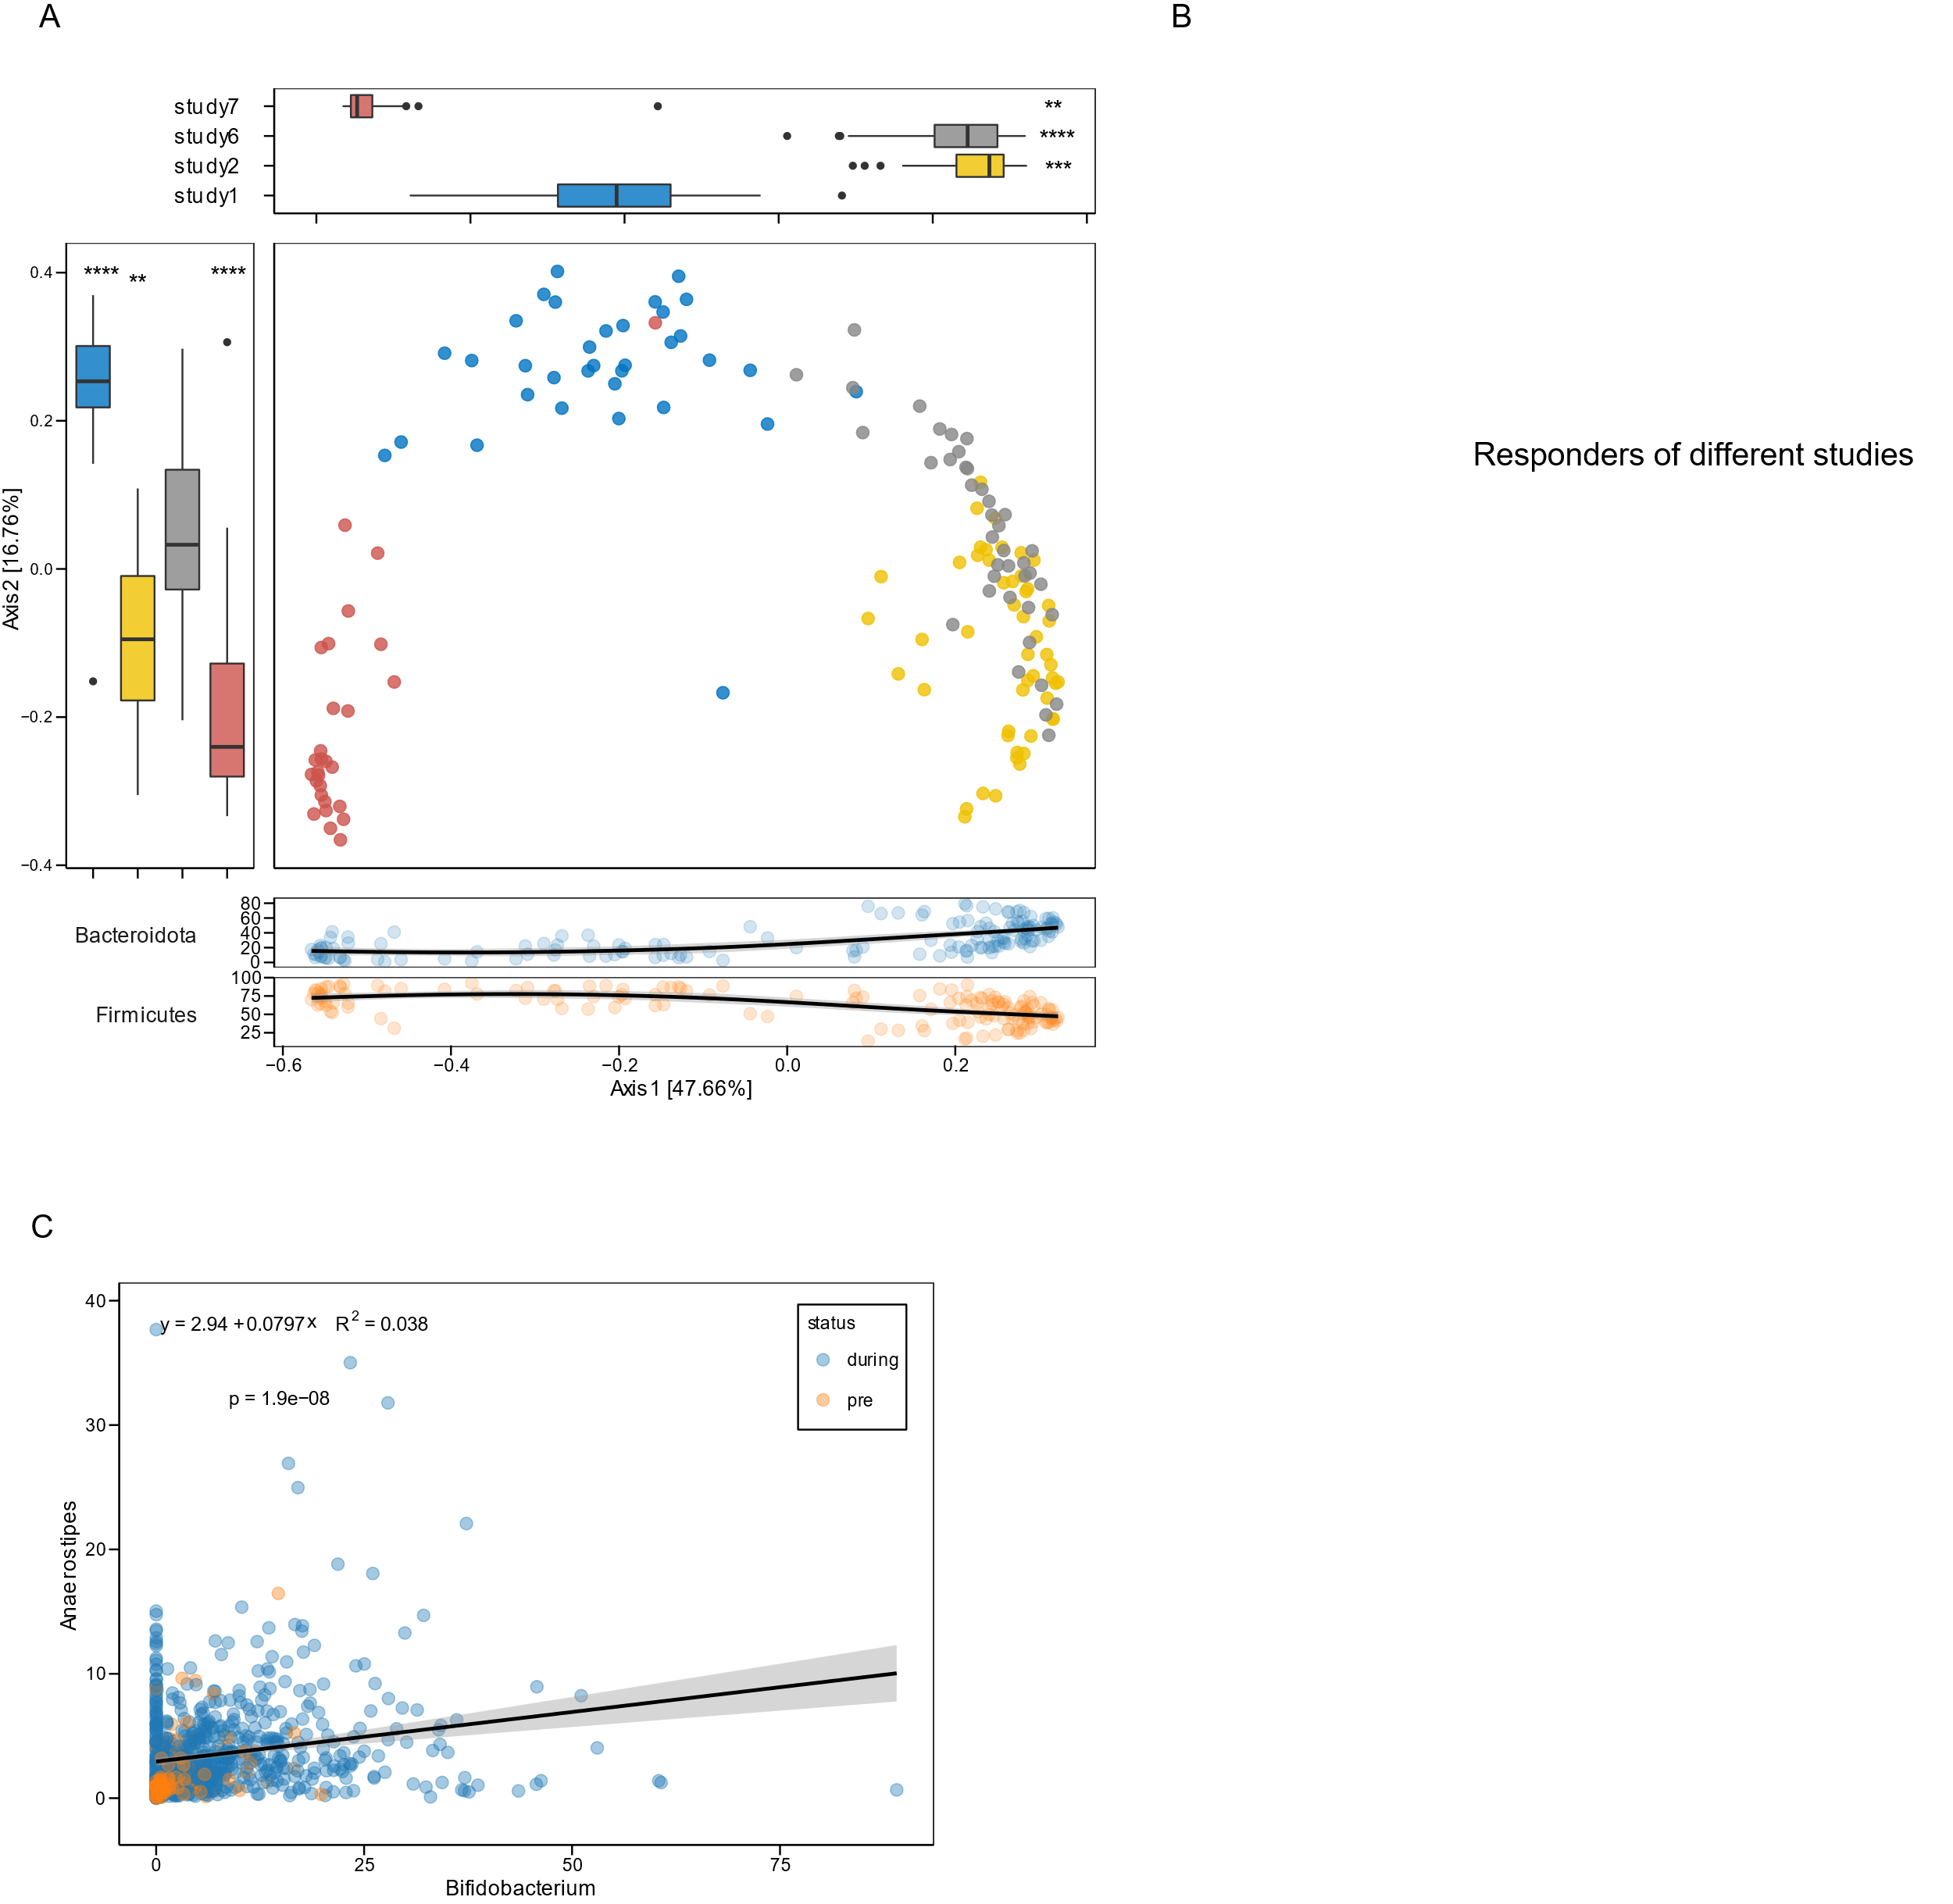

**Figure. Meta-analysis of inulin responders using human data.**

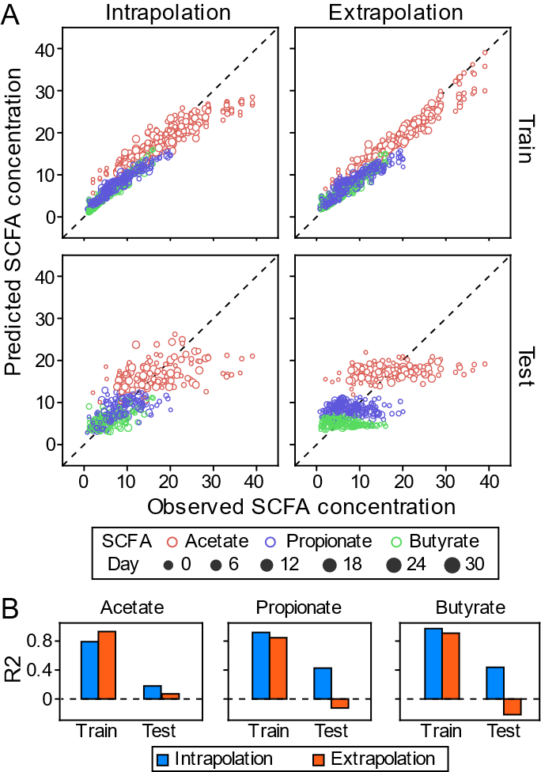

**Figure 4. Microbiome-SCFA prediction is baseline-dependent.**

**SCFA~Microbiome**

1. Transition: cartoon (what is training data, what is test data) : from Figure 1B
2. Prediction: difference among SCFA
3. plot importance heatmap? Or in supplement

supplement: Show fitted time series

1. Extrapolation (predict dynamics of other vendors) has limited predictive power.

Use Pearson?

better for similar baseline

Supplement: MelonnPan (training data, test data) ->Hongbin

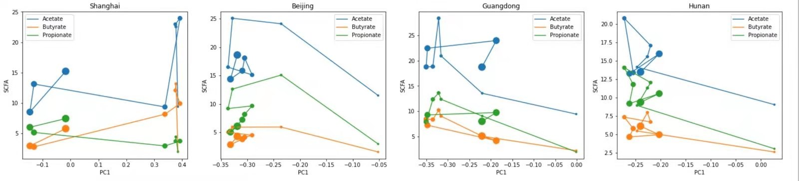

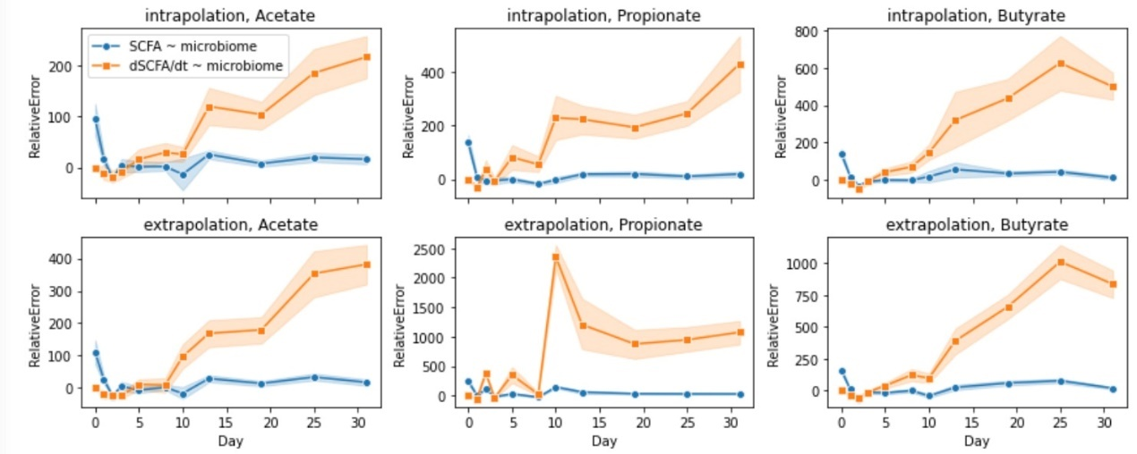

**Figure 5. The relationship between microbiome and SCFA production is different at short and long timescales.**

A)show data: SCFA vs. microbiome composition (absolute abundance, the same as Figure 4) over time

B)Pearson correlation?

Supplement: show dSCFA/dt~Microbiome: R^2 (bad)

dSCFA/dt vs. d(microbiome)/dt: do not show

Timescale的讨论

大部分人的分析：SCFA 在t和t+1的差值 与microbiome 在t和t+1的差值，而不是microbiome 在t时刻的组成

菌群组成：决定了此刻的SCFA量，还是SCFA的差值

**Methods**

*Animal experiment*

Specific-pathogen-free (SPF) female C57BL/6J mice for different gut microbial composition were obtained at 6 weeks of age from Beijing (A Charles River Company, Beijing, China), Hunan (Hunan Slac Jingda Laboratory Animal Company, Ltd., Changsha, China), Guangdong (Guangdong Medical Laboratory Animal Center, Foshan, China)), Shanghai (SLAC Laboratory Animal Co., Ltd., Shanghai, China). Mice were maintained on a 12-h light/dark cycle and allowed ad libitum access to food and water throughout the experiment. After acclimatizing to the diet and housing environment for 1 week, mice from each vendor were randomly separated into three groups: cellulose group, resistant starch group, and inulin group (n = 5). Composition of all diets including the source of dietary fibers inulin, cellulose and pectin are provided in supplementary table 1 (Table S1). Fecal pellets from each mouse were freshly collected over multiple time points: day 0 (before diet change), day 1, 3, 5, 8, 13, 19, 25, and 31 (Figure 1A). Fecal samples were snap-frozen in liquid nitrogen and stored at −80 °C until further processing. At every cage change (moving the mice to a new clean cage with fresh bedding once in two weeks), body weight was individually measured, and food intake and fecal output of each cage mice during the past three days per cage were measured. This study was performed in accordance with the recommendations of the National Care and Use of Animals Guidelines (China) and approved by the Institutional Animal Care and Use Committee (IACUC) of the Shenzhen Institutes of Advanced Technology, Chinese Academy of Sciences.

*GC-MS analysis of fecal SCFA concentration*

The SCFAs were analyzed according to the previous studies with modifications. For the sample extraction, 0.05 g of frozen feces were mixed with 300 µL of pure water containing caproic acid-6,6,6-d3 (CDN Isotopes, Quebec, Canada) as internal standard (IS, final concentration 20 µg/mL). After adding 1.0 mm diameter zirconia/silica beads (BioSpec, Bartlesville, OK), feces were homogenized for 20 s under 6500 rpm for three times, then incubated at 4 °C with shaking for 30 min, followed by centrifugation for 30 min at 13,000×g. Following extraction with anhydrous diethyl ether, the SCFA extract accurately transferred into a glass insert in a GC vial and capped tightly after added 5 µl of N, O-bis(trimethyl-silyl)-trifluoroacetamide and vortexed for 5 s. The mixture was kept in the GC vial and incubated at room temperature (22 °C) overnight (or over 8 h) before loading to GC/MS. The analysis of acetic, propionic and butyric acids was performed by Agilent 8890/7000D triple quadrupole GC/MS equipped with a capillary HP-5 ms capillary column (30 m × 0.25 mm × 0.25 µm film thickness) (Agilent Technologies). The analytes were quantified in the selected ion monitoring (SIM) mode using the target ion and confirmed by confirmative ions. The concentration was determined with reference to the peak side of IS.

*DNA extraction and quantification of bacterial load*

For extraction of DNA, 0.25 g of fecal material from pellets was extracted using the QIAmp PowerFecal DNA kit (Qiagen, #12830–50) following standard manufacturer procedures. DNA samples were resuspended in Buffer C6 and quantitated using the Qubit fluorometer (ThermoFisher Scientific). To quantitatively assess bacterial load, total bacteria cell counts were determined using qPCR as described recently.

*Amplicon and metagenomic sequencing*

16S rRNA gene sequencing was performed as previously described. Library preparation was done using a two-step PCR method. During the first step of PCR, primers *S-D-Bact-0341-b-S-17* and *S-D-Bact-0785-a-A-21* were used to target and amplify the v3-4 region, as well as to add second-step priming sites. Dual index codes were added to each sample using ALFA-SEQ DNA Library Prep Kit (mCHIP) at the second PCR step. The PCR products were purified with Agencourt AMPure XP magnetic beads (Beckman Coulter, Brea, CA, USA) and quality controlled with TapeStation (Agilent Technologies, Santa Clara, CA, USA). The final DNA concentrations of the purified products were measured with a Qubit 2.0 fluorometer (Thermo Fisher Scientific). The purified products were pooled in equal molar concentrations, and denatured following the Illumina protocol. All sequencing was done in a single run, which was performed with a 250-cycle SP kit on the NovaSeq 6000 following the NovaSeq XP workflow (Illumina, USA).

Metagenomic sequencing was performed using fecal samples from the inulin diet group at day 0, 5 and 31. Extracted DNA sample was purified using silica-based columns and then used to construct a shotgun library, which was sequenced with a 150-cycle S4 kit on the NovaSeq 6000 following the NovaSeq XP workflow (Illumina, USA).

*Sequence analysis*

The 16S rRNA sequencing reads were analyzed in QIIME 2-2020.2 software (37). Demultiplexed paired-end reads were trimmed to remove primers and poor quality bases with q2-cutadapt plugin. The trimmed sequences were denoised and joined with q2-dada2 plugin. The generated feature table was filtered to remove ASVs present in only a single sample and remaining ASVs were used to construct a rooted phylogenetic tree via q2-phylogeny. Rarefaction curve analysis of the data obtained was used to estimate the completeness of microbial communities sampling and performed using the iNEXT R package. Subsequently, in order to avoid sample-to-sample bias due to variable sequencing depth (different number of reads per sample), samples were rarefied to 38,980 sequences per sample and estimated alpha diversity metrics, beta diversity metrics and Principle Coordinate Analysis (PCoA) using q2-diversity. Group significance between alpha and beta diversity indexes was calculated with QIIME2 plugins using the Kruskal–Wallis test and permutational multivariate analysis of variance (PERMANOVA), respectively. To assign taxonomy to the amplicon sequence variants (ASVs), the q2-feature-classifier basing on the classify-sklearn naïve Bayes taxonomy classifier was used with the SILVA (v.138) as reference database.

For metagenome analysis, raw sequencing reads were subjected to quality filtering and barcode trimming using KneadData (v0.5.4) by employing trimmomatic settings of 4-base wide sliding window, with average quality per base >20 and minimum length 90 bp. Reads mapping to the mouse genome were also removed. Kraken2 was run against genome taxonomy database (GTDB_r89_54k) with default parameters. Following classification by Kraken2, Bracken was used to re-estimate bacterial abundances at taxonomic levels from species to phylum using a read length parameter of 150. Next, the filtered sequences were assembled into contigs using metaSPAdes with default settings. Functional analysis of the contigs was done with DRAM. Putative genes were then predicted on contigs longer than 200 base pairs using Prodigal under metagenome mode (-p meta). A non-redundant gene catalogue was constructed with CD-HIT using the parameters “-c 0.95 –aS 0.9”. The abundance of each predicted gene was evaluated by mapping reads back with KMA algorithm and then normalized with the following equation: RPM = 1M × (mapped reads/gene length)/(sum of mapped reads/gene length). All the genes were clustered into Co-Abundance Groups (CAGs) based on their abundance as previously described. For all the predicted genes, CAZymes were annotated using hmmsearch against the dbCAN database V9 (e value <1 × 10−10; coverage >0.3). The domain with the highest coverage was selected for sequences overlapping multiple CAZyme domains.

*Statistical analysis*

R packages *qiime2R*, *ANCOM*, *phyloseq*, *DESeq2*, *RandomForests*, *vegan*, *cluster*, *ggpubr*, *ggtern*, *rstatix*, and *ggplot2* were used for normalization, analyses, and visualization. For normally distributed continuous variables, the mean values were examined using an unpaired Student’s t test or One-way ANOVA with Tukey’s post hoc test. The level of significance was set at *P*<0.05. Differential CAZY genes and bacterial CAGs between time points were identified using Wilcoxon matched-pair signed-rank tests (two-tailed) followed by FDR corrections. Linear discriminant analysis effect size (LEfSe), a method for biomarker discovery, was used to determine taxa that best characterize the gut microbiome of different vendors.

**References**

[1]. Lynch, S.V. and O. Pedersen, The Human Intestinal Microbiome in Health and Disease. New England Journal of Medicine, 2016.

[2]. Sanna, S., et al., Causal relationships among the gut microbiome, short-chain fatty acids and metabolic diseases. Nature Genetics, 2019. 51(4): p. 600-605.

[3]. Nomura, M., et al., Association of Short-Chain Fatty Acids in the Gut Microbiome With Clinical Response to Treatment With Nivolumab or Pembrolizumab in Patients With Solid Cancer Tumors. JAMA Network Open, 2020. 3(4): p. e202895.

[4]. Harkins, C.P., H.H. Kong and J.A. Segre, Manipulating the Human Microbiome to Manage Disease. JAMA, 2019. 323(4): p. 303.

[5]. Zhao, L., et al., Gut bacteria selectively promoted by dietary fibers alleviate type 2 diabetes. Science, 2018. 359(6380): p. 1151-1156.

[6]. Valcheva, R., et al., Inulin-type fructans improve active ulcerative colitis associated with microbiota changes and increased short-chain fatty acids levels. Gut Microbes, 2019. 10(3): p. 334-357.

[7]. Creswell, R., et al., High-resolution temporal profiling of the human gut microbiome reveals consistent and cascading alterations in response to dietary glycans. Genome Medicine, 2020. 12(1).

[8]. Solden, L.M., et al., Interspecies cross-feeding orchestrates carbon degradation in the rumen ecosystem. Nature Microbiology, 2018. 3(11): p. 1274-1284.

[9]. Falony, G., et al., Cross-Feeding between Bifidobacterium longum BB536 and Acetate-Converting, Butyrate-Producing Colon Bacteria during Growth on Oligofructose. Applied and Environmental Microbiology, 2006. 72(12): p. 7835-7841.

[10]. Cockburn, D.W. and N.M. Koropatkin, Polysaccharide Degradation by the Intestinal Microbiota and Its Influence on Human Health and Disease. J Mol Biol, 2016. 428(16): p. 3230-3252.

[11]. Ze, X., et al., Ruminococcus bromii is a keystone species for the degradation of resistant starch in the human colon. ISME J, 2012. 6(8): p. 1535-43.

[12]. Salonen, A., et al., Impact of diet and individual variation on intestinal microbiota composition and fermentation products in obese men. ISME J, 2014. 8(11): p. 2218-30.

[13]. Lloyd-Price, J., et al., Multi-omics of the gut microbial ecosystem in inflammatory bowel diseases. Nature, 2019. 569(7758): p. 655-662.

[14]. Bokulich, N.A., et al., q2-longitudinal: Longitudinal and Paired-Sample Analyses of Microbiome Data. mSystems, 2018. 3(6): p. e00219-18.

[15]. Chijiiwa, R., et al., Single-cell genomics of uncultured bacteria reveals dietary fiber responders in the mouse gut microbiota. Microbiome, 2020. 8(1): p. 5-14

.

[16]. Belzer, C., et al., Microbial Metabolic Networks at the Mucus Layer Lead to Diet-Independent Butyrate and Vitamin B12 Production by Intestinal Symbionts. mBio, 2017. 8(5).

[17]. Le Bastard, Q., et al., The effects of inulin on gut microbial composition: a systematic review of evidence from human studies. European Journal of Clinical Microbiology & Infectious Diseases, 2019.

[18]. Schell, M.A., et al., The genome sequence of Bifidobacterium longum reflects its adaptation to the human gastrointestinal tract. Proc Natl Acad Sci U S A, 2002. 99(22): p. 14422-7.

[19]. Vogt, J.A. and T.M.S. Wolever, Fecal Acetate Is Inversely Related to Acetate Absorption from the Human Rectum and Distal Colon. The Journal of nutrition, 2003. 133(10): p. 3145-3148.

[20]. Rahat-Rozenbloom, S., et al., Evidence for greater production of colonic short chain fatty acids in overweight than lean humans. International Journal of Obesity, 2014.

[21]. Sakata, T., Pitfalls in short-chain fatty acid research: A methodological review. Animal Science Journal, 2019. 90(1): p. 3-13.

[22]. McOrist, A.L., et al., Fecal Butyrate Levels Vary Widely among Individuals but Are Usually Increased by a Diet High in Resistant Starch. Journal of Nutrition, 2011. 141(5): p. 883-889.

[23]. Haenen, D., et al., A Diet High in Resistant Starch Modulates Microbiota Composition, SCFA Concentrations, and Gene Expression in Pig Intestine. Journal of Nutrition, 2013. 143(3): p. 274-283.

[24]. Baxter, N.T., et al., Dynamics of Human Gut Microbiota and Short-Chain Fatty Acids in Response to Dietary Interventions with Three Fermentable Fibers. MBio, 2019. 10(1).

[25]. Baxter, N.T., et al., The Glucoamylase Inhibitor Acarbose Has a Diet-Dependent and Reversible Effect on the Murine Gut Microbiome. mSphere, 2019. 4(1).

[26]. Walker, A.W., et al., Dominant and diet-responsive groups of bacteria within the human colonic microbiota. ISME J, 2011. 5(2): p. 220-30.

[27]. David, L.A., et al., Diet rapidly and reproducibly alters the human gut microbiome. Nature, 2014. 505(7484): p. 559-63.

[28]. Hiel, S., et al., Effects of a diet based on inulin-rich vegetables on gut health and nutritional behavior in healthy humans. Am J Clin Nutr, 2019. 109(6): p. 1683-1695.

[29]. Wu, G.D., et al., Linking long-term dietary patterns with gut microbial enterotypes. Science, 2011. 334(6052): p. 105-8.

[30]. Nordgaard, I., et al., Colonic production of butyrate in patients with previous colonic cancer during long-term treatment with dietary fibre (Plantago ovata seeds). Scand J Gastroenterol, 1996. 31(10): p. 1011-20.

[31]. Fragiadakis, G.K., et al., Long-term dietary intervention reveals resilience of the gut microbiota despite changes in diet and weight. The American Journal of Clinical Nutrition, 2020.

[32]. Korem, T., et al., Bread Affects Clinical Parameters and Induces Gut Microbiome-Associated Personal Glycemic Responses. Cell Metab, 2017. 25(6): p. 1243-1253.e5.

[33]. Sonnenburg, E.D., et al., Diet-induced extinctions in the gut microbiota compound over generations. Nature, 2016. 529(7585): p. 212-215.

[34]. Kolida, S., D. Meyer and G.R. Gibson, A double-blind placebo-controlled study to establish the bifidogenic dose of inulin in healthy humans. Eur J Clin Nutr, 2007. 61(10): p. 1189-95.

[35]. de Preter, V., et al., Baseline microbiota activity and initial bifidobacteria counts influence responses to prebiotic dosing in healthy subjects. Aliment Pharmacol Ther, 2008. 27(6): p. 504-13.

[36]. Ramirez-Farias, C., et al., Effect of inulin on the human gut microbiota: stimulation of Bifidobacterium adolescentis and Faecalibacterium prausnitzii. Br J Nutr, 2009. 101(4): p. 541-50.

[37]. Healey, G., et al., Habitual dietary fibre intake influences gut microbiota response to an inulin-type fructan prebiotic: a randomised, double-blind, placebo-controlled, cross-over, human intervention study. British Journal of Nutrition, 2018. 119(2): p. 176-189.

[38]. Dewulf, E.M., et al., Insight into the prebiotic concept: lessons from an exploratory, double blind intervention study with inulin-type fructans in obese women. Gut, 2013. 62(8): p. 1112-1121.

[39]. Nakayama, J., et al., Impact of Westernized Diet on Gut Microbiota in Children on Leyte Island. Frontiers in Microbiology, 2017. 8.

[40]. Vandeputte, D., et al., Prebiotic inulin-type fructans induce specific changes in the human gut microbiota. Gut, 2017: p. gutjnl-2016-313271.

[41]. Scott, K.P., et al., Prebiotic stimulation of human colonic butyrate-producing bacteria and bifidobacteria, in vitro. FEMS Microbiol Ecol, 2014. 87(1): p. 30-40.

[42]. Myhill, L.J., et al., Fermentable Dietary Fiber Promotes Helminth Infection and Exacerbates Host Inflammatory Responses. J Immunol, 2020. 204(11): p. 3042-3055.

NE.Bib

**Supplementary figures and tables**

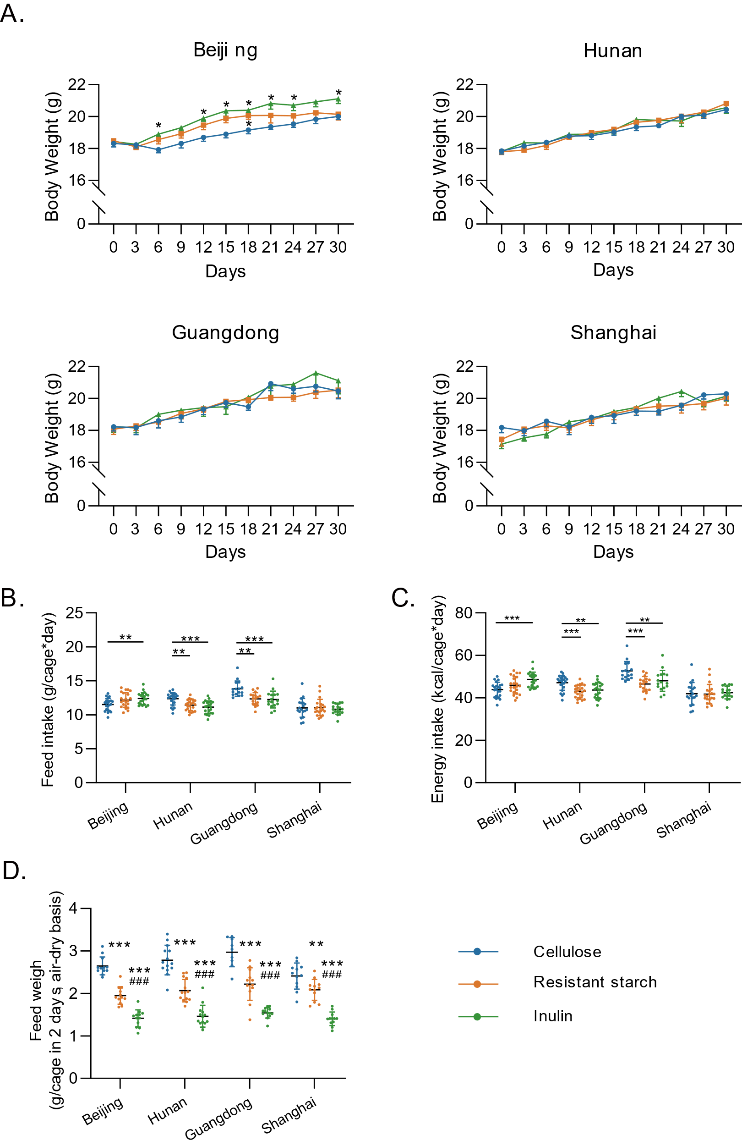

Figure S1. The effect of inulin or resistant starch supplementation on (A) body weight, (B) daily food intake, (C) daily energy intake, and (D) 48-hr fecal output. Data were analyzed with ordinary one-way ANOVA with Turkey post hoc test. * *P* < 0.05, ** *P* < 0.01, and *** *P* < 0.001 vs cellulose group; ### *P* < 0.001 vs resistant starch group.

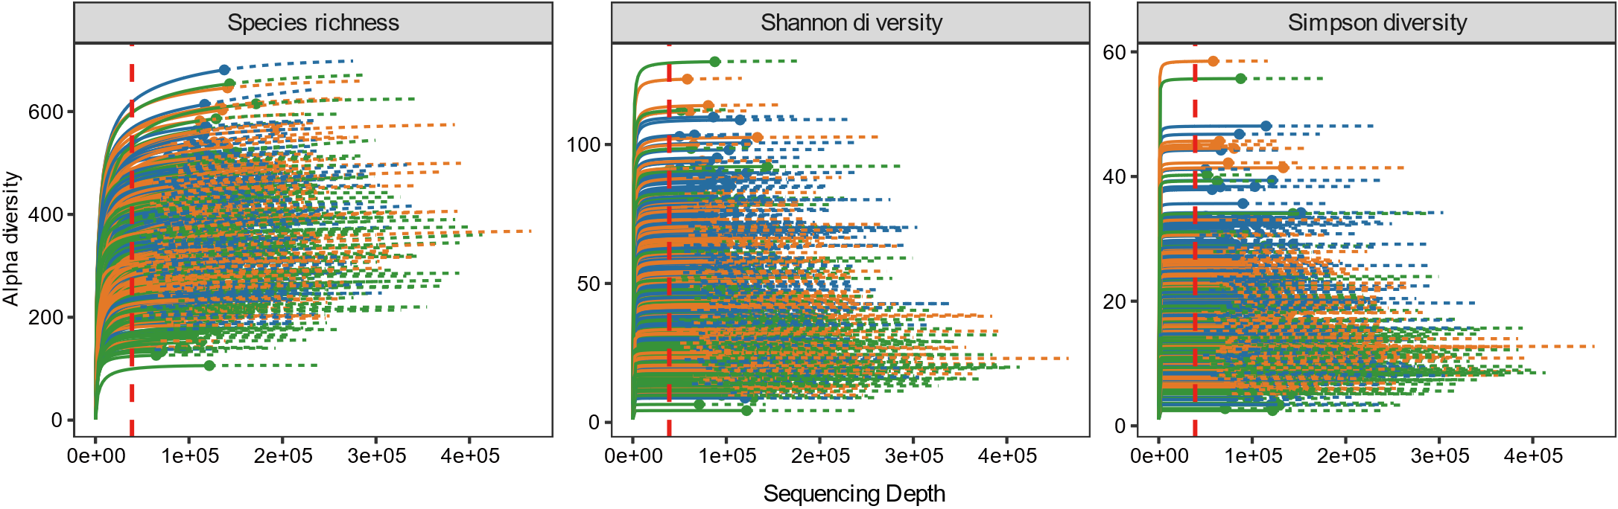

Figure S2. Rarefaction analysis of 16S rRNA gene clone libraries in terms of species richness (A), Shannon diversity (B), and simpson diversity (C). Rarefaction curves were generated with the iNEXT package. Solid lines represent the observed accumulation with the number of reads sampled, and dashed lines represent the extrapolated accumulation considering 25% more reads.

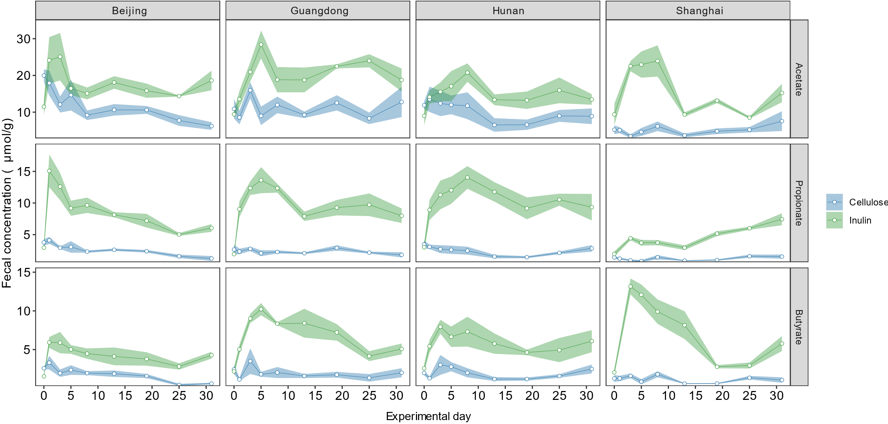

Figure S3. Individual SCFA concentration in fecal samples from different vendors over time.

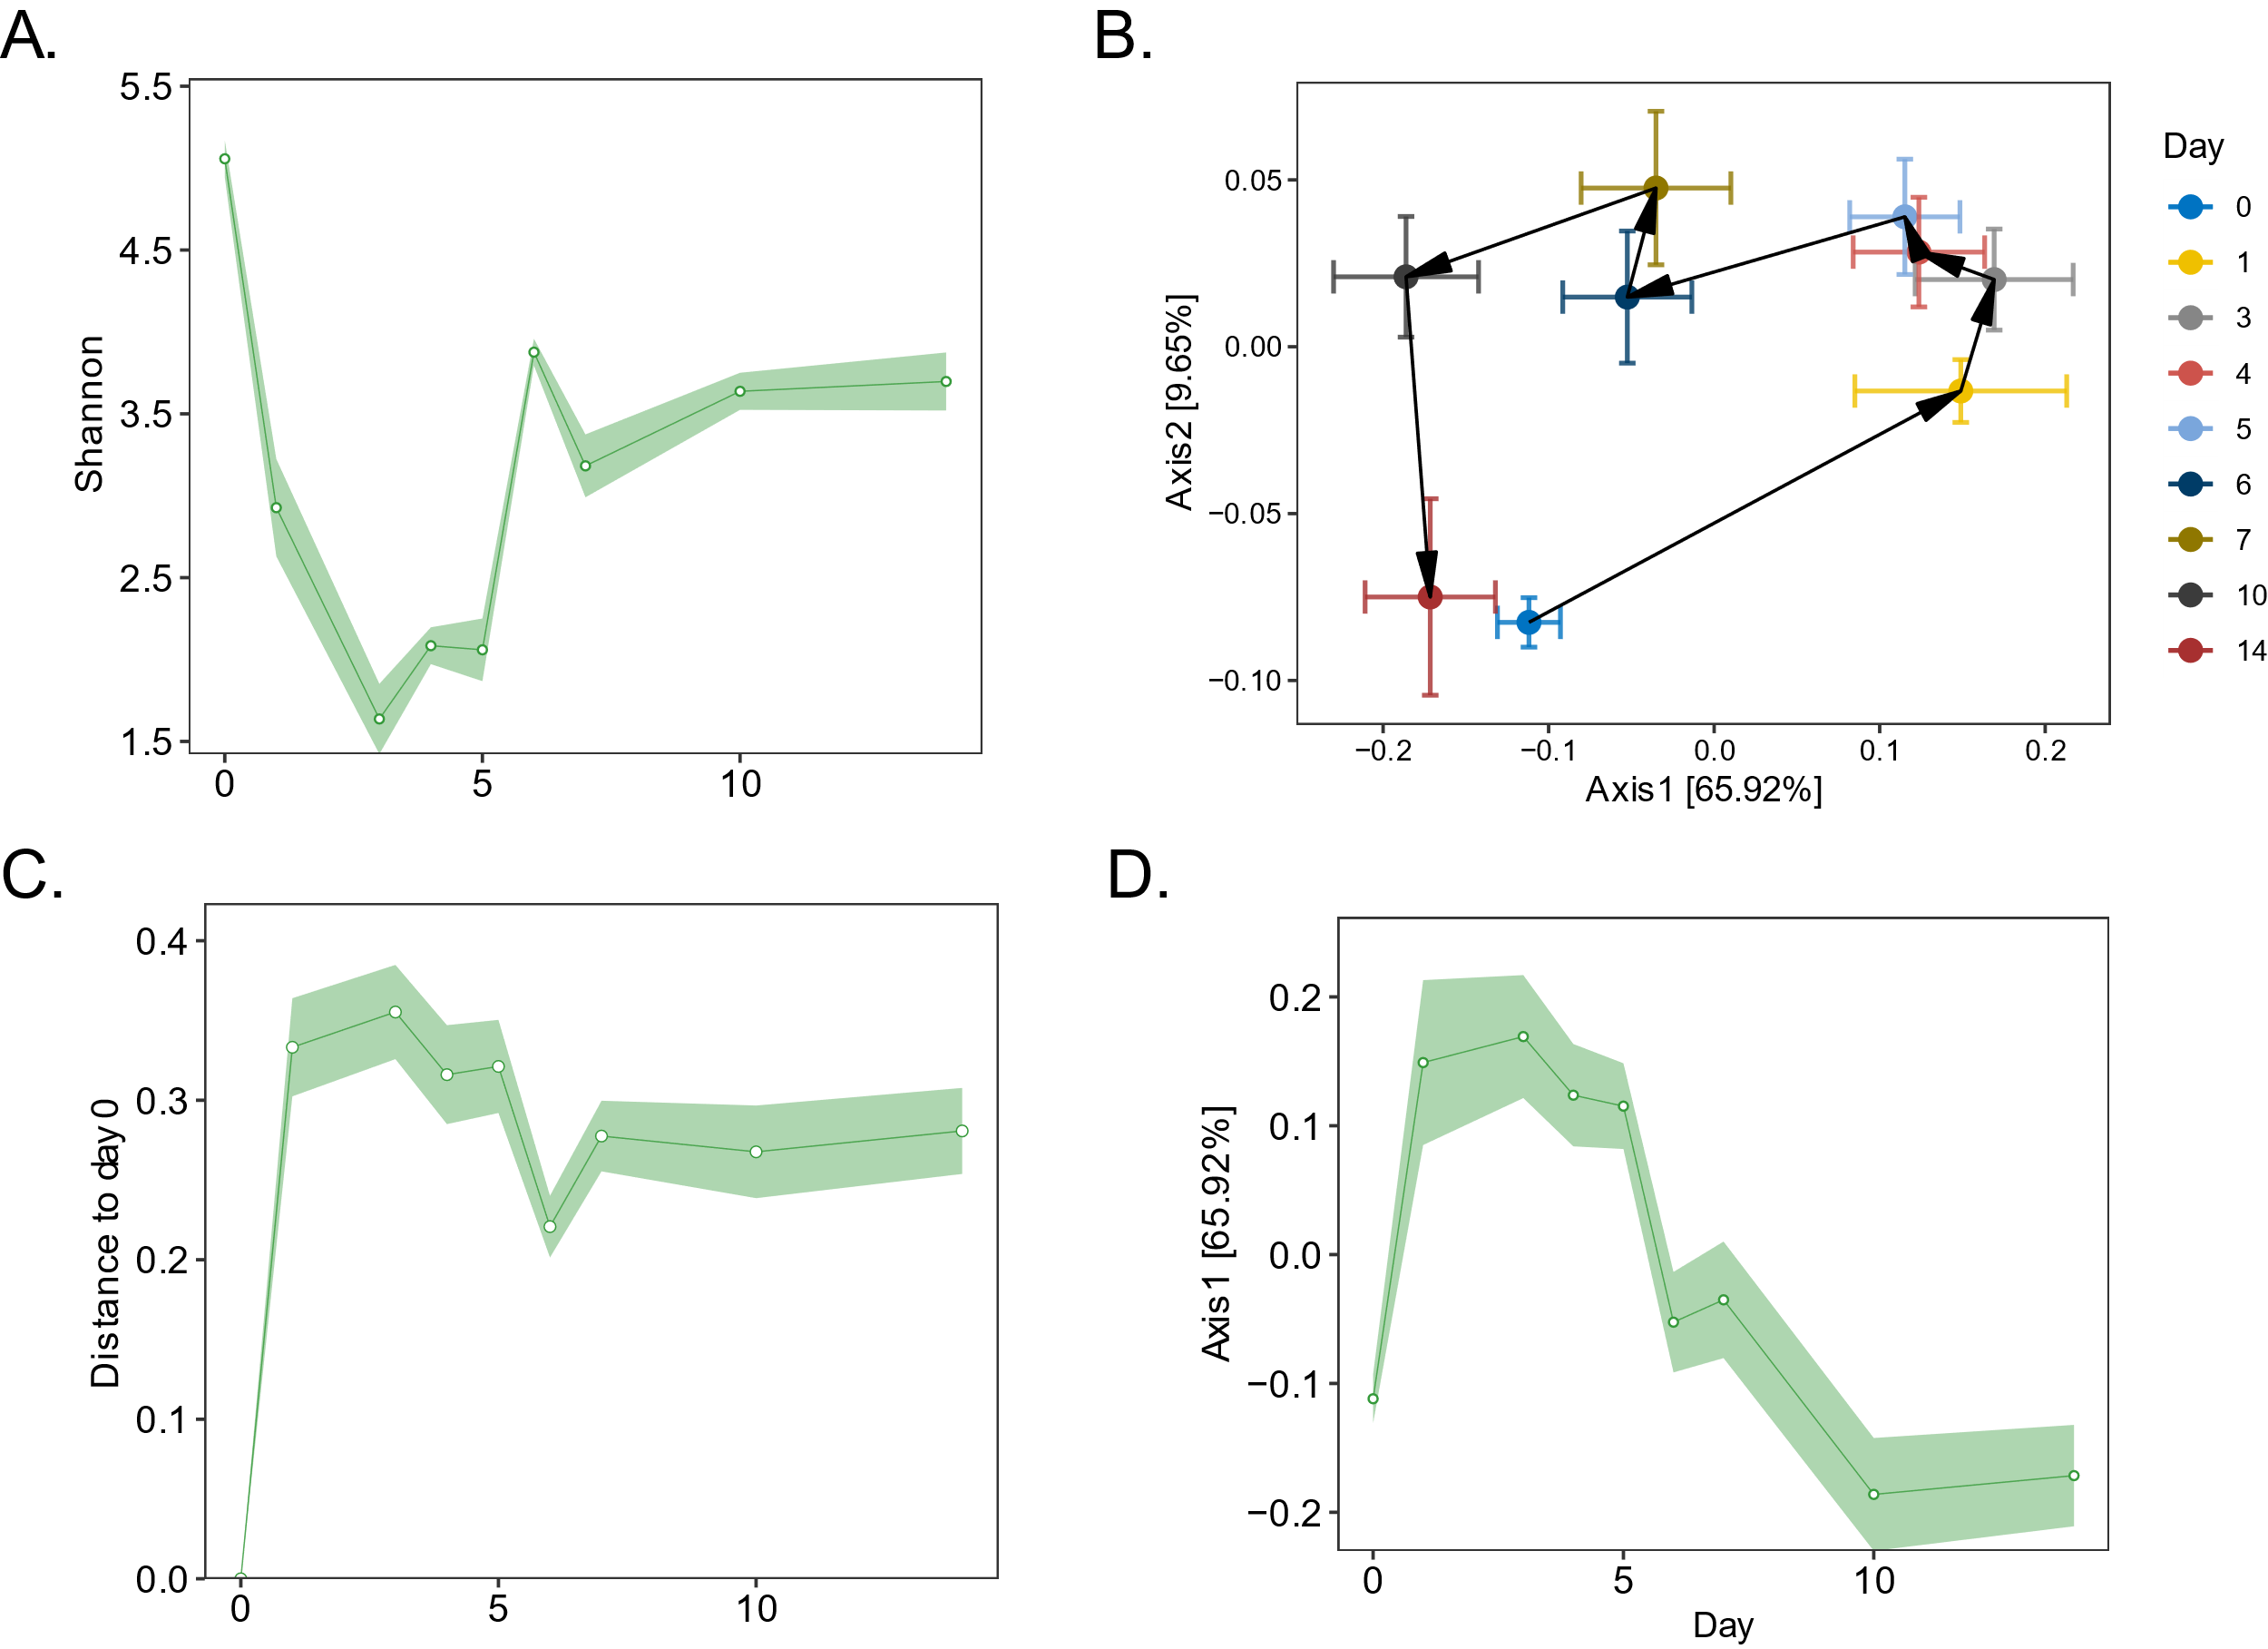

Figure S4. Consistent observation of biphasic response of mouse gut microbiome to dietary inulin in study 1.

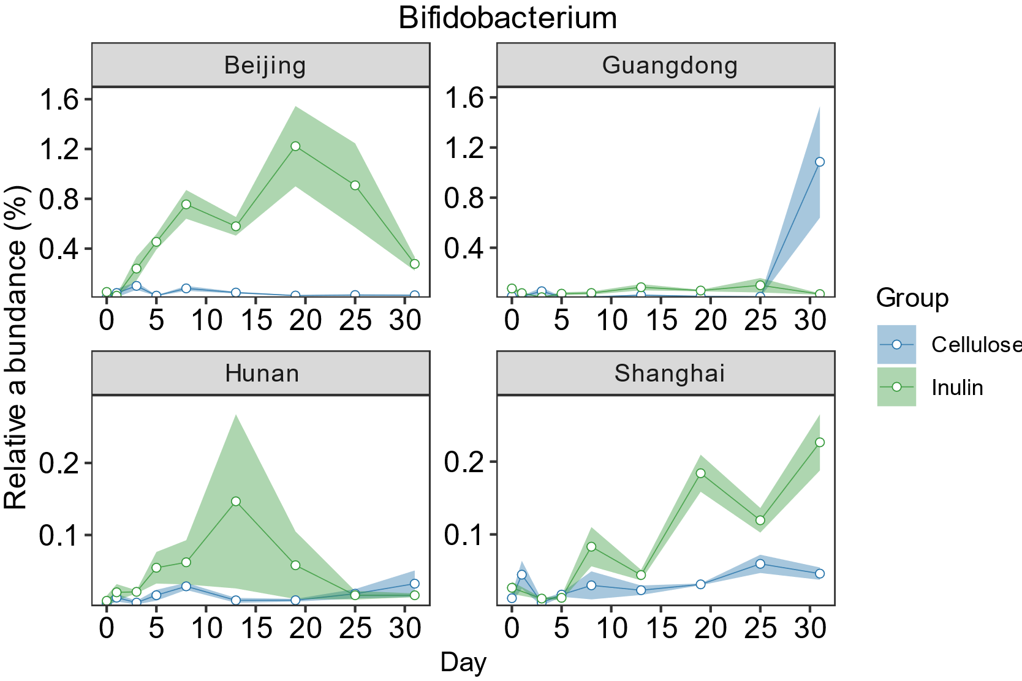

Figure S5. Dynamics of the relative abundance of *Bifidobacterium* to dietary inulin.

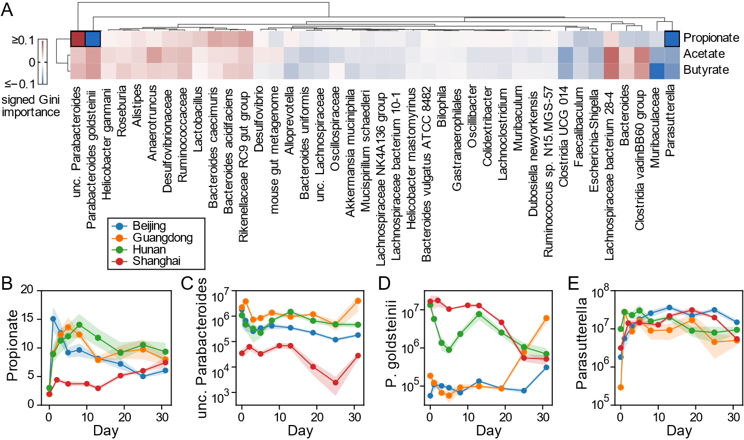

**Figure. Identification of SCFA fermenters.**

show individual SCFA production time series

Machine learning: find association between microbial species/genus and SCFA production

Supp table: SCFA producers

Filter criterion: top 40/100 absolute abundance + importance threshold. Some taxonomy labels are confusing

|  |  |  |  |  |  |  |
| --- | --- | --- | --- | --- | --- | --- |
| Table S1 Diets used in study. | | | | | | |
|  | **Cellulose** | | **Type Ⅱ RS (Corn)** | | **Inulin** | |
| **Ingredient** | **g** | **kcal** | **g** | **kcal** | **g** | **kcal** |
| Casein | 200 | 800 | 200 | 800 | 200 | 800 |
| L-cystine | 3 | 12 | 3 | 12 | 3 | 12 |
| Corn starch | 379.486 | 1517.944 | 326.486 | 1305.944 | 379.486 | 1517.944 |
| Maltodextrin | 130 | 520 | 130 | 520 | 130 | 520 |
| Sucrose | 100 | 400 | 100 | 400 | 100 | 400 |
| Cellulose | 100 | 0 | 20 | 0 | 20 | 0 |
| Inulin or RS | 0 | 0 | 133 | 172.9 | 80 | 116.8 |
| Soybean oil | 70 | 630 | 70 | 630 | 70 | 630 |
| t-butylhydroquinone | 0.014 | 0 | 0.014 | 0 | 0.014 | 0 |
| AIN Mineral mix | 35 | 0 | 35 | 0 | 35 | 0 |
| S10022G |  | 0 |  | 0 |  | 0 |
| AIN Vitamin mix | 10 | 40 | 10 | 40 | 10 | 40 |
| V10037 |  | 0 |  | 0 |  | 0 |
| Choline bitartrate | 2.5 | 0 | 2.5 | 0 | 2.5 | 0 |
| Total | 1030 | 3919.944 | 1030 | 3880.844 | 1030 | 4036.744 |
|  | **g%** | **kcal%** | **g%** | **kcal%** | **g%** | **kcal%** |
| Protein | 19.42 | 20.41 | 19.42 | 20.61 | 19.42 | 19.82 |
| Carbohydrate | 69.85 | 63.21 | 69.85 | 62.84 | 69.85 | 64.28 |
| Fat | 6.80 | 16.07 | 6.80 | 16.23 | 6.80 | 15.61 |
| Total |  | 99.69 |  | 99.69 |  | 99.70 |
| kcal/gm |  | 3.81 |  | 3.77 |  | 3.92 |
| Resistant polysaccharide | | 9.71 |  | 9.69 |  | 9.71 |

Type Ⅱ RS (Corn): HI-MAIZE® 260 resistant starch, 1.3kcal/g, contain 60% dietary fiber.

Inulin: Orafti® HP, High performance Inulin powder for fat replacement at low processing temperatures, ~94.5% Insulin (Average DP >=23, DP = 2–60), DP = Degree of Polymerization. 1.5kcal/g.

Mineral mix and vitamin mix are both AIN-93G.

Table S2 Reported bacterial SCFA metabolizers.

|  |  |  |  |
| --- | --- | --- | --- |
| **Bacterial species/group** | **Metabolism** | **Model** | **Reference** |
| *Eubacterium rectale* | butyrate | Human | [3] |
| *Faecalibacterium prausnitzii* | butyrate | Human | [3] |
| *Parabacteroides goldsteinii* | acetate, succinate | Human | [7] |
| *Lachnospiraceae bacterium 28-4* | butyrate | Mosue | [8] |
| *Lachnospiraceae* | acetate,propionate,butyrate | Human | [9,12] |
| *Ruminococcaceae* | acetate,propionate,butyrate | Human | [10] |
| *Clostridiaceae* | acetate,propionate,butyrate | Human | [10, 11] |
| *Peptococcaceae* | butyrate | Human | [9] |
| *Bacteroides* | acetate,propionate | Human | [10] |
| *Parasutterella* | succinate | Mosue,Human | [13] |
| *Anaerotruncus* | acetate, butyrate, Succinate | Human | [11,14] |
| *Lactobacillus* | acetate |  |  |

[3]. Moens, F. and L. De Vuyst, Inulin-type fructan degradation capacity of Clostridium cluster IV and XIVa butyrate-producing colon bacteria and their associated metabolic outcomes. Beneficial Microbes, 2017. 8(3): p. 473-490.

[4]. Li, L., et al., Inulin with different degrees of polymerization protects against diet-induced endotoxemia and inflammation in association with gut microbiota regulation in mice. Scientific reports, 2020. 10(1): p. 978-12.

[5]. Zhu, L., et al., Inulin with different degrees of polymerization modulates composition of intestinal microbiota in mice. FEMS Microbiology Letters, 2017. 364(10).

[6]. Chijiiwa, R., et al., Single-cell genomics of uncultured bacteria reveals dietary fiber responders in the mouse gut microbiota. Microbiome, 2020. 8(1): p. 5-14

[7]. Song, Y., et al., "Bacteroides goldsteinii sp. nov." isolated from clinical specimens of human intestinal origin. J Clin Microbiol, 2005. 43(9): p. 4522-7.

[8]. Daniel, S.G., et al., Functional Changes in the Gut Microbiome Contribute to Transforming Growth Factor beta-Deficient Colon Cancer. mSystems, 2017. 2(5).

[9]. Vital, M., A.C. Howe and J.M. Tiedje, Revealing the bacterial butyrate synthesis pathways by analyzing (meta)genomic data. mBio, 2014. 5(2): p. e00889.

[10]. Louis, P. and H.J. Flint, Formation of propionate and butyrate by the human colonic microbiota. Environmental Microbiology, 2017. 19(1): p. 29-41.

[11]. Vital, M., et al., A gene-targeted approach to investigate the intestinal butyrate-producing bacterial community. Microbiome, 2013. 1(1): p. 8.

[12]. Vacca, M., et al., The Controversial Role of Human Gut Lachnospiraceae. Microorganisms, 2020. 8(4): p. 573.

[13]. Ju, T., et al., Defining the role of Parasutterella, a previously uncharacterized member of the core gut microbiota. The ISME Journal, 2019. 13(6): p. 1520-1534.

[14]. Esquivel-Elizondo, S., et al., Insights into Butyrate Production in a Controlled Fermentation System via Gene Predictions. mSystems, 2017. 2(4).

Table S3 Reported bacterial fiber degraders.

|  |  |  |  |
| --- | --- | --- | --- |
| **Bacterial species/group** | **Fiber** | **Model** | **Reference** |
| *Ruminococcus bromii* | Hi-maize 958 | Human | [1] |
| *Bifidobacterium adolescentis* | Hi-maize 958 | Human | [1] |
| *Bifidobacterium adolescentis* | resistant potato starch | Human | [2] |
| *Bifidobacterium faecale* | resistant potato starch | Human | [2] |
| *Bifidobacterium stercoris* | resistant potato starch | Human | [2] |
| *Eubacterium rectale* | Inulin | Human | [3] |
| *Faecalibacterium prausnitzii* | Inulin | Human | [3] |
| *Muribaculaceae* | Inulin | C57BL/6J mice | [4] |
| *Muribaculaceae* | Inulin | C57BL/6J mice | [5] |
| *Bacteroides acidifaciens* | Inulin | C57BL/6J mice | [6] |

[1]. Ze, X., et al., Ruminococcus bromii is a keystone species for the degradation of resistant starch in the human colon. ISME J, 2012. 6(8): p. 1535-43.

[2]. Baxter, N.T., et al., Dynamics of Human Gut Microbiota and Short-Chain Fatty Acids in Response to Dietary Interventions with Three Fermentable Fibers. MBio, 2019. 10(1).

[3]. Moens, F. and L. De Vuyst, Inulin-type fructan degradation capacity of Clostridium cluster IV and XIVa butyrate-producing colon bacteria and their associated metabolic outcomes. Beneficial Microbes, 2017. 8(3): p. 473-490.

[4]. Li, L., et al., Inulin with different degrees of polymerization protects against diet-induced endotoxemia and inflammation in association with gut microbiota regulation in mice. Scientific reports, 2020. 10(1): p. 978-12.

[5]. Zhu, L., et al., Inulin with different degrees of polymerization modulates composition of intestinal microbiota in mice. FEMS Microbiology Letters, 2017. 364(10).

[6]. Chijiiwa, R., et al., Single-cell genomics of uncultured bacteria reveals dietary fiber responders in the mouse gut microbiota. Microbiome, 2020. 8(1): p. 5-14